

***Obstetric and gynecological nursing Department***

***Courses codes (301-nursing)***

***Reproductive Health Nursing***

***Final exam for 3rd year students***

**Date:3 /1/2017 Time allowed: 3 hour Total marks: 80**

**Important Instructions For All Students: Please Read Carefully**

|  |  |
| --- | --- |
| Allocated time | 3 hours |
| Total allocated marks | (80 marks) |
| Number of papers | ( papers) |
| Number of questions | ( questions ) |
| How to answer | choose the correct answer for MCQ , matching, true / false &write the answers for the questions below  (incomplete-situation ) |
| Attention | All questions are to be answered |

**ملحوظة هامة :-امتحان الشفوي سوف يعقد في نفس اليوم عقب الانتهاء من الامتحان التحربري بالدور الثالث بقسم تمريض صحة المرأة والتوليد**

**I- 🖎Choose the best answer: M arks (17.5 )**

**1- Fertilization of the ovum by sperm normally occurs in the ?**

1. **Fimbria of the fallopian tube**
2. **Isthmus of the fallopian tube**
3. **Ampulla part of the fallopian tube**
4. **Uterine cornua of the fallopian tube**

**2- which of the following forms is used to describe the darkening of the face that may occur during pregnancy ?**

1. **chloasma**
2. **linea Nigra**
3. **spider nevi**
4. **Angioma**

**3-How often should prenatal care visits occur during the first trimester?**

1. **Monthly**
2. **Once**
3. **Weekly**
4. **Daily**

**4- The fluid that surrounds the fetus before birth is called :**

1. **Blood**
2. **Amniotic fluid**
3. **Chorionic fluid**
4. **Mucus**

**5- At term the uterus weight approximately :**

1. **200 gm**
2. **500 gm**
3. **1000 gm**
4. **2500 gm**

**6- During the third stage of labour :**

1. **The baby is born**
2. **Maternal cervical dilatation occurs**
3. **The beginning of cervical dilatation occurs**
4. **The placenta is delivered**

**7- Second stage of labour is defined as :**

1. **Onset of labour and full dilatation**
2. **Dilatation from 7 to 10 cm**
3. **Delivery of the fetus**
4. **Delivery of placenta**

**8- Production of milk is promoted by**

1. **Oxytocin**
2. **Prolactin**
3. **Oestrogen**
4. **Progesterone**

**9- Mona is 28 weeks of pregnancy attending first time ante natal clinic her LMP. is 30 April 2016 the EDD. is**

1. **30 – 1 -2017**
2. **7 -2 - 2017**
3. **7 -2 – 2016**
4. **14 – 12- 2016**

**10- Mrs. Lamia, 40 wks pregnant women is admitted in the antenatal ward. Your abdominal palpation to Mrs Lamia gave you the following findings, answer questions 10 to 14 :dark brown line extending from the symphisis pubic to umbilicus. This called**

1. **Linea nigra**
2. **Striae gravidarum**
3. **Caesarean scar**
4. **Chloasma**

**11- on palpation to fundus you get a hard round mass the fetal part this is :**

1. **Sacrum**
2. **Head**
3. **Hand**
4. **Leg**

**12- on palpation of left side of abdomen revealed smooth curved part this is :**

1. **Thigh of the fetus**
2. **Abdomen of the fetus**
3. **Head of the fetus**
4. **Back of the fetus**

**13- Based on the above Assessment what is the fetal lie ?**

1. **Longitudinal**
2. **Transverse**
3. **Oblique**
4. **Non of the above**

**14- you are auscultating the fetal heart beats for Mrs. Lamia. What is the normal FHR you expect ?**

1. **100 beats / minute**
2. **70 beats / minute**
3. **140 beats / minute**
4. **172 beats / minute**

**15- Alia told the nurse that she wants her next baby only after 2 years . which of the following method is an easy and effective method of contraception for her ?**

1. **withdrawal method**
2. **vasectomy for her husband**
3. **tubal ligation for her**
4. **oral contraceptive pills**

**16- Awomen has just delivered a healthy girl , but the the placenta has not yet been delivered . what stage of labour does this scenario represent ?**

1. **first stage**
2. **second stage**
3. **third stage**
4. **fourth stage**

**17- a pregnant woman has a fever of 39 C and reports abdominal pain and a bad smell to her lochia , what diagnosis do you suspect ?**

1. **mastitis**
2. **endometritis**
3. **subinvolution**
4. **episiotomy infection**

**18- A pregnant woman has a LMP of 20 – 11- 2016 the gestational age for that woman on 27 -5-2017 will be :-**

1. **27 week**
2. **26 week**
3. **24 week**
4. **25 weeks**

**19- Maternal indication for induction of labor**

1. Post-term pregnancy
2. Pre-term pregnancy
3. Major degree placenta praevia
4. Major degree of cephalo-pelvic disproportion

**20- Heba has been experiencing regular, coordinated contractions with cervical dilatation moving from 4 cm to 6 cm in the last half hour, and her membranes are still intact; Heba is in which stage of labor?**

a- latent phase of the first stage of labor

b- Active phase of the first stage of labor

c- The third stage of labor

d- The second stage of labor

**21- The female clitoris is homologous to which of the following male body parts:-**

a- scrotum b- prostate

c - Frenulum d- penis

**22- Engagement is best defined as which of the following**

a - when the presenting part goes through the pelvic inlet

b - When the presenting part is level with the ischial spines

c - When the greatest biparietal diameter of the fetal head passes the pelvic inlet

**23- Which of the following is a characteristic posture of pregnancy?**

a- kyphosis b- hyperextension

c- lordosis d – scoliosis

**24- The time between the beginning of one uterine contractions to the end of the same contraction is:** a. intensity  
 b. interval  
 c. duration  
 d. frequency

**25- The main causes of constipation during pregnancy are**

1. decrease physical exertion
2. changes in the diet
3. relaxation of the smooth muscle system
4. obstruction to the lower bowel bowel by the presenting part of the fetus

**26-Premarure rupture of the membranes is most strictly defined as spontaneous rupture at the end of ?**

* + 1. the second stage of labor
    2. the 32nd week of gestation
    3. the third stage
    4. first stage of labour

**27- From the following definitions, select the best description of preterm labor**.

* 1. labor that begins after 28 weeks’ gestation and before 37 weeks’ gestation
  2. labor that begins after 15 weeks’ gestation and before 37 weeks’ gestation
  3. labor that begins after 24 weeks’ gestation and before 28 weeks’ gestation
  4. labor that begins after 28 weeks’ gestation and before 40 weeks’ gestation

**28- Following delivery of healthy baby, which one is first to be done:**

A- To place the baby on comfortable position .

B- To clear the air passage and maintain patent air way.

C- Eye care for newborn.

D- Clamping the umbilical cord.

**29- Perception of fetal movement by multigravida pregnant women:**

A- 6-8 weeks

B- 16-18 weeks

C- 30 - 36 weeks

D- None of the above

**30- The uterus is a hollow, muscular and ………….**

1. pear –shaped organ
2. orange –shaped organ
3. almond –shaped organ

**31-The pregnant uterus reach the umbilical level at**

a. 9 weeks b. 10 weeks

c .24 weeks d. 36 weeks

**32- A 36 years old client is admitted with a ruptured ectopic pregnancy. The nurse will prepare client for**

**A-** Dilation and curettage. B-- U/S

C-Evacuation of uterus D-Salpingectomy

**33- Which of the following conditions necessitate follow up for one year Human chorionic gondatrophin hormone testing**

**A-** client who had septic abortion

B- client who had ectopic pregnancy

C-client who had vesicular mole

D-client who had premature cervical dilation

**34- A couple with one child had been trying, without success for several years to have another child. Which of the following terms would describe the situation?**  
a. Primary Infertility b. Secondary Infertility  
c. Irreversible infertility d. Sterility

**35- Magnesium sulphate give to mother complain from**

1. Heart disease b.Eclampsia

c-.Renal failure d.Respiratory depress

**11. 🖎 Matching:(13 marks)**

|  |  |
| --- | --- |
| **Column (A)** | **Column (B)** |
| 1- Three part organ (basalis, capsularis, and vera) that is discard following the birth of a child | a- Labor |
| 2- Hormone responsible for a positive pregnancy test is | b- Decidua |
| 3- Contact between the blastocyst and the uterine endometrial occurring about 6th to 8th day of fertilization. | c- Attitude |
| 4- Surrounded the umbilical cord vein and arteries | d- Abruptio placenta |
| 5- Implantation occurring outside the uterine cavity | e- Goodell' signs |
| 6- Placenta implemented in the lower uterine of the uterus | f- Wharton’s jelly |
| 7- Premature separation of placenta | g- implantation |
| 8-The degree of flexion the fetus assumes or the relation of the fetal parts to each other | h- Human chorionic gondatrophin |
| 9- A series of events by which uterine contractions expel the fetus and placenta from the woman’s body | i- Placenta previa |
| 10- Softening of cervix related to increased vascularity | t. Crowning |
| 11- It is excessive blood loss at delivery that affecting the general condition of the mother | j- Ectopic pregnancy |
| 12-It is a spasmodic colicky pain in the lower abdomen during the early postpartum days due to vigorous uterine contraction | k- Chadwick's signs |
| 13-Top of fetal head is visible during…………. | o- post partum haemorrhage |
| |  |  |  |  |  |  |  |  |  |  |  |  |  | | --- | --- | --- | --- | --- | --- | --- | --- | --- | --- | --- | --- | --- | | 1 | 2 | 3 | 4 | 5 | 6 | 7 | 8 | 9 | 10 | 11 | 12 | 13 | | b | h | g | f | j | i | d | c | a | e | o | w | t | | l- Follicle stimulating hormone |
|  | w- After pain |

**Part 111:- ( Each question carries one marks)Total 15 Marks Put (A) for the true statement and (B)for the wrong one**

|  |  |  |
| --- | --- | --- |
| **1** | The pregnant uterus reach the umbilical level at 12 weeks | **B** |
| **2** | Bluish violet discoloration of the Vagina is called Chadwick’s sign | **A** |
| **3** | Placenta praevia is a type of normal attachment of placenta. | **B** |
| **4** | The functional life span of the ovum is about 48 hours / may be as long as 72 hours or longer | **B** |
| **5** | The inner cell mass of blastocyst is called the embryonic mass and will form embryo | **A** |
| **6** | Habitual abortion defined as :Three or more consecutive spontaneous abortions | **A** |
| **7** | common etiologic factor for ectopic pregnancy is history of pelvic inflammatory disease (PID) | **A** |
| **8** | Megaloblastic anemia is type of anemia caused by Folic acid deficien | **A** |
| **9** | Pregnant woman is considered sever anemic when the hemoglobin below 7 gm/dl | **A** |
| **10** | Eating foods high in vitamin C makes iron absorption more efficient | **A** |
| **11** | Diabetes mellitus associated with pregnancy is a significant factor contributing to prenatal morbidity | **A** |
| **12** | **involution is failure return the uterus to pre pregnant condition** | **B** |
| **13** | Lochia discharge is alkaline in reaction | **B** |
| **14** | Lochia serosa is white discharge that last one day only | **B** |
| **15** | Full bladder is a predisposing factor for a tonic post-partum hemorrhage | **A** |





**1V . 🖎 Complete the following:-( 10 marks )**

1- **List Function of the amniotic Fluid:**

1. Protection of the fetus from external trauma.
2. Facilitates the movement of the fetus.
3. Nutrition.
4. Excretion of the fetal urine.
5. Contains antiseptic so it prevents infection.

2- **List Risk of precipitate labor for mother and fetus :**

*Contractions can be so forceful that they lead to* **:**

* + - premature separation of the placenta
    - placing the mother and fetus at risk for hemorrhage.
    - sudden release of pressure on the fetal head lead to subdural hemorrhage.
    - lacerations of the birth canal from the forceful birth.

3- **List Stages of an eclamptic fits:**

*A. Premonitory stage: (less than 10-20 seconds).*

*B. Tonic stages: (lasts 10-20 second).*

*C. Clonic stages: (lasts 60-90 seconds).*

*D. Stage of coma:*

*4-***Classify heart disease during pregnancy based on function not diagnosis ?**

1. class I Asymptomatic on ordinary physical activity.
2. class II symptomatic with ordinary physical activity.
3. class III symptomatic with less than ordinary physical activity. –
4. class IV symptomatic are present at rest ( de-compensated )

***5-List* Symptoms of prolapse:**

1-Before actual prolapse. the patient feels a sensation of weakness in the perineum. particularly towards the end of the day.

2. Later the patient notices a mass which appears on straining. and disappears when she lies down.

3. Urinary symptoms are common and trouble some even with slight prolapse:

a) Urgency and frequency by day.

b) Stress incontinence.

c) Inability to micturate unless the anterior vaginal wall is pushed upwards by the patient's fingers.

d) Frequency and scalding day and night when cystitis develops

.

**V1 . 🖎 Situation :( 22.5 marks )**

Mrs .Azza her 36 year married for 15 year pregnant for fourth time have two child admitted to labour unit with cervix dilatation 8 cm and 80% effacement and after general examination transverse to delivery room within two hour delivered normally.

1. List characteristics of normal labour ?
2. Differentiate between true labour pain and false labour pain ?
3. list mechanism of normal labour?
4. Discuss nursing management of third stage of labour?

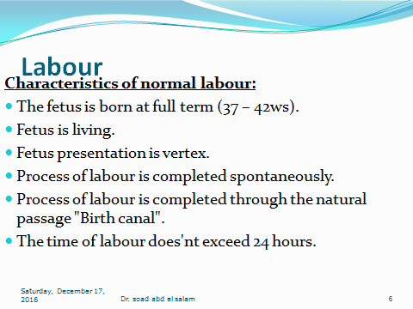

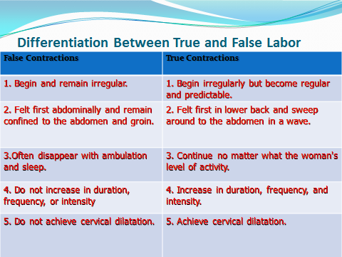

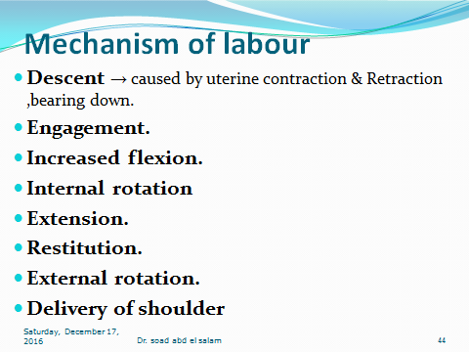

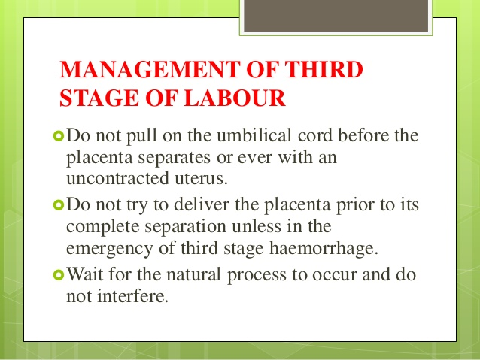

**Team work :-**

**1-prof. :Dr. Amal omran**

**2-Ass. prof. :Dr. soad abd el salam**

**3-Ass. prof. :Dr. Azeza Ibrahim**

**4-Ass. prof. :Dr.Hend abd Alla**

**5 – Dr. rehab Mohamed abdelhady**

**6-Lecturer :Dr. somia ooda**

**7-Lecturer :Dr. samaha abd el haleem**

**8-Lecturer :Dr.Eman abdelhakam**

**9-Lecturer :Dr. Afaf Emam**

**10-Lecturer :Dr.Amira Refat**

**11-Lecturer :Dr.hanan amin**

**12-Lecturer :Dr.Hemad moustafa**

**13-Lecturer :Dr. amira salama**

**14-Lecturer :Dr.Elham abo zed**

**With The Best Wishes**

**Chairman of department**

**Dr. Soad abdelsalam**